**Scan, Shop & Exchange**

###### **MUHAMMAD FAIZAN**

###### **HAMZA ZAREEN**



DEPARTMENT OF COMPUTER SCIENCES

COMSATS UNIVERSITY ISLAMABAD,

ATTOCK CAMPUS – PAKISTAN

# SESSION 2018-2022

**Scan, Shop & Exchange**

### *Undertaken By:*

###### **MUHAMMAD FAIZAN**

CIIT/SP18-Bcs-009/ATK

###### **HAMZA ZAREEN**

CIIT/SP18-Bcs-024/ATK

#### Supervised By:

**MR JAMAL AHMED**

A DISSERTATION SUBMITTED AS A PARTIAL FULFILLMENT OF THE REQUIREMENTS FOR THE DEGREE OF BACHELOR OF SCIENCE IN COMPUTER SCIENCE

### 

### DEPARTMENT OF COMPUTER SCIENCES

### COMSATS UNIVERSITY ISLAMABAD,

##### ATTOCK CAMPUS – PAKISTAN

# 

# SESSION 2018-2022

UNDERTAKEN

We certify that this is my/our own work. The work has not, in whole or in part, been presented elsewhere for assessment. Where material has been used from other sources it has been properly acknowledged. If this statement is untrue, we acknowledge that we will have committed an assessment offence and shall be liable to punishable action under the plagiarism rules of HEC.

___________________­­­­­­­­­­­­­­ __________________

Muhammad Faizan Hamza Zareen

SP18-BCS-009 SP18-BCS-024

Dated: _________ Dated: _________

**FINAL APPROVAL**

Certified that we have read this project report submitted by Mr. (Muhammad Faizan & Hamza Zareen) and it is, in our judgment, of sufficient standard to warrant its acceptance by Department of Computer Science, Comsats University Islamabad, Attock Campus, for the (BS degree) in Computer Science.

***Committee:***

1. External Examiner ____________________________

(Examiner Name)

Designation

University Name

2. Supervisor Mr. Jamal Ahmed

(Supervisor Name)

3. Chairperson ____________________________

(Chairperson Name)

4. Dean/Director ____________________________

(Dean/Director Name)

**DEDICATION**

*Every challenging work needs self-effects as well as guidance of elders especially those who were very close to our hearts.*

*We dedicate all of our efforts to beloved*

ALLAH (s.w.t)

*The creator, a source of inspiration, wisdom, knowledge and understanding for us.*

Prophet Muhammad (PBUH)

*A great Teacher, mentor and inspiration for us in each and every field of life.*

Father and mother

*Whose affection, love, kindness, and prays make us able to get such success and honor in the life.*

Teachers

*For always believing in us, inspiring us, and encouraging us to reach higher in order to achieve our goals.*

**ACKNOWLEDGMENT**

In the Name of Allah, the Most Gracious, the Most Merciful. First, we would like to thank our parents and teachers who supported us in all times, both financially and morally.

We would also like to thank Sir Jamal Ahmed for his guidance to work hard. We have found him very helpful in the discussion related to our project. His critical comments on our work have made us think about new ideas. We are grateful to Allah Almighty who provided us every kind of resources to make this project for the benefit of the mankind.

**PROJECT BRIEF**

PROJECT NAME SCAN, SHOP & EXCHANGE

ORGANIZATION NAME COMSATS UNIVERSITY ISLAMABAD, ATTOCK CAMPUS

OBJECTIVE TO PROVIDE EASY WAY OF SHOPPING

UNDERTAKEN BY MUHAMMAD FAIZAN (SP18-BCS-024)

HAMZA ZAREEN (SP18-BCS-024)

SUPERVISED BY MR JAMAL AHMED

LECTURER

COMPUTER SCEINCES

CUI, ATTOCK CAMPUS

Started On 05 MARCH, 2021

Completed On

COMPUTER USED HP & DELL

SOURCE LANGUAGE ANDROID STUDIO

OPERATING SYSTEM WNIDOWS 10

**ABSTRACT**

People use internet to know about information in all fields of life. Internet is a very best platform to get information as well as now it has become a way for shopping also. This increase has created a demand for developers to develop an application that provides ease for the people.

We are developing an android application which will be used for shopping but our application will be different from other common shopping applications. Our application has the scan and shop feature where a person scans an image of product and will be transferred to shopping sites where he can find that product as well as similar products. Another interesting feature of our application will be barter exchange, where user will not only be able to buy new and used products but also they would be able to find the replace of their product near to them, It means if someone wants to replace any product with any other product he wants, so it can easily be done as our application will make it possible for them by finding the correct person who will be also willing to replace the item. Moreover, our application will also provide similar items based on item-to-item and user-to-user collaborative filtering so that they can also try them as well.

**TABLE OF CONTENTS**

TABLE OF CONTENTS

CH# TITLE PAGE NO

**CHAPTER 1 INTRODUCTION 12**

* 1. Introduction 13
  2. Objectives 13
  3. Modules 13
  4. Problem Statement 13
  5. Conclusion 14

**CHAPTER 2 LITERATURE REVIEW 15**

2.1 Literature Review 16

2.1.1 Existing Applications 16

2.1.1.1 Daraz 16

2.1.1.2 AliExpress 17

2.2 Conclusion 17

**CHAPTER 3 PROPOSED METHODOLOGY 18**

3.1 Non Functional Requirements 19

3.1.1 Performance 19

3.1.2 Response Time 19

3.1.3 Security 19

3.1.4 Usability 19

3.1.5 Testability 19

3.2 Functional Requirements 20

3.3 Proposed Solution 20

3.4 Conclusion 20

**CHAPTER 4 PROJECT DESIGN 22**

4.1 Activity Diagram 22

4.2 Use Case Diagram 24

4.3 Context Diagram 25

4.4 Sequence diagram 27

4.5 Conclusion 28

**List of Figures**

Figure 1 Activity Diagram 24

Figure 2 Use Case Diagram 26

Figure 3 Context Diagram 27

Figure 4 Sequence Diagram of User Login 28

Figure 5 Sequence diagram of User Buying or Exchanging Product 29

**List of Tables**

Table 1 17

Chapter 1

# Introduction

# Introduction

This project is aimed at developing an android application to make shopping easy. Using this Application, customers will easily find products they will be looking for, but it is not easy to define something you have seen in specific keywords. That’s the area where this application will be useful, because it will find the products user will looking for by taking the picture, For example: if someone likes his/her friend’s watch and wants the same, He/she should have to take a picture of that watch and the application will find that watch for him/her from where they can buy it. It will be the easiest way to purchase products.

As Shopping is one of the areas where more and more people find it convenient to buy products, but sometimes people don’t want to buy product, they want to just barter their product with others. This application will provide that functionality as well and also near to them by tracking their location.

This application will also generate a recommendation list of items they may also like. That recommended list will be containing similar items they searched or looking for.

# 1.2 Objectives

* The goal is to create a full flash android application that will bring a revolution in shopping industry.
* The working of project will be image processing by taking the picture with camera and finding the places from where people will buy or barter that thing.
* The whole searching process will be done from the picture.
* The application will also provide similar items based on item-to-item and user-to-user collaborative filtering so that they can also try them as well.
* The main objective of project is to make a user friendly interface and easy to use shopping application.

# 1.3 Modules

* Login Page: User will login after registering himself with us.
* Home Page: Some items from database are shown.
* Category: Search for the product in a specific category.
* Search bar: Using search icon.
* Multiple products: Proceed for checkout.
* Barter Exchange: New and used products.
* Recommended System: Through ML products which are bought many times will be shown on home page for specified user, also some new products will be recommended based on search.

# 1.4 Problem Statement

There are the most popular applications used for shopping. But none of them provides the functionality of scan and shop as well as item exchange. These features make our application unique.

# 1.5 Conclusion

The concept of project basically come from online shopping like amazon.com and daraz.pk etc. but the idea of shopping items online is something new then all that.

User just have to open the application, take the picture and application will find that specific site or website where the product will be present , if there is no product available then the application will find some related one and also will give some suggestions and recommendations. One and the most interesting feature of this application will be barter exchange, it means if someone wants to exchange his product with any other product he likes, he has to just click on the barter button and write his choice of product in the textfield or by taking picture and this application will find the correct match for user, if there is none then some suggestions and recommendations will be provided. It will also provide the facility of location as GPS tracking, the user has just to select the place from where they want to buy or exchange products. To cut the story short, the main goal is to bring change in way people use to shop and to make the shopping easy to the maximum possible extent.

* Time Saving.
* Ease to find products and ordering.
* Barter Exchange.

Chapter 2

# Literature Review

# 2.1 Literature Review

## There have been hundreds of applications developed in which mostly involved in the Store management system, online shop.

When we searched, we found different types of applications for online shopping which only search by keywords.

## 2.1.1 Existing Apps:

|  |  |  |
| --- | --- | --- |
| **S No** | **Name** | **Functionality** |
| 1 | Daraz | Online Marketplace |
| 2 | AliExpress | Online Shopping App |
| 3 | OLX | Online Old & New Products App |
| 4 | Amazon | Ecommerce App |
| 5 | Zalora | Online fashion and Makeup App |

Table 1

### 2.1.1.1 Daraz

Daraz is an [online marketplace](https://en.wikipedia.org/wiki/Online_marketplace) and logistics company which operates in markets of [South Asia](https://en.wikipedia.org/wiki/South_Asia) and Asia. It was founded in 2012 as an online fashion e-commerce marketplace in Pakistan.

**Features:**

* Official store
* Daily flash sales
* Easy and secure checkout
* Top up and e store

### 2.1.1.2 Ali Express

Ali Express is an [online retail](https://en.wikipedia.org/wiki/Online_retail) service based in [China](https://en.wikipedia.org/wiki/China) that is owned by the Alibaba Group. Launched in 2010 it is made up of small businesses in China and other locations, such as [Singapore](https://en.wikipedia.org/wiki/Singapore), that offer products to international online buyers. It is the most visited e-commerce website in [Russia](https://en.wikipedia.org/wiki/Russia) and was the 10th most popular website in [Brazil](https://en.wikipedia.org/wiki/Brazil).

## Features:

* Enables shoppers to find affordable goods
* Get coupons.
* Look for discount in the mobile application
* Check out the shock price selection every day

# 2.2 Conclusion

In this chapter, we discuss the previous applications which are related with this app. We compare this application with previous applications. We compare features which are different in this app and discuss all the features which are present in previous apps. We found different applications which are only for search by keyword, no option for taking picture and searching is present there, which create problem for those who want the same thing when they see it somewhere, so for this purpose we are developing an application which will be providing the option of taking picture and searching it. The user has to just login to the application then he has to choose an option of searching, if it is of taking picture then he has to just take the picture and the application will search that thing for the user, if there is none, some suggestion and recommendation will be given, there is also another feature that can be used by those people who want to barter something with any other person the item they want.

Chapter 3

# Proposed Methodology

# 3.1 Non Functional requirements:

These are the non functional requirements which are described below.

## 3.1.1 Performance

The system will be able to perform all the tasks efficiently. All the features which we introduced in this app are performing all the functionality properly, like searching items by keyword, taking picture or barter exchange.

## 3.1.2 Response time

The system will be able to respond in few seconds. It is easy to install and take just few seconds to install if your internet availability is much better. Also the response time will be good in searching items, finding the exact partner for barter exchange.

## 3.1.3 Security

All the data will be secured as they will be done through private profiles. Data of all the users is secured in this app. Users can enter in this app with full security. His username and password should be encrypted; no third party will be able to access it.

## 3.1.4 Usability

The application shall be easy enough to be used by any user. This application is helpful to all because online shopping application are nowadays commonly used, so it will be easy to use for all users, because it will be self explanatory, as the button and icons will used in such way that every person will be able to easily understands its functionality.

## 3.1.5 Testability

This application is tested and all the features like login, sign up, searching products, are working properly as needed. The overall functionality of the system is proper and accordingly.

# 3.2 Functional requirements:

* Initially user will be registered in this app.
* Next time user has to just login.
* Allow user to choose new, old and barter products.
* System maintains the database of the Customers.
* Security of the data.

# 3.3 Proposed Solution

As there is no such facility for the Customers that provides the user picture taking facility therefore, we will develop this android based app in which, when User logins or registers and after that they will be able to choose searching criteria, they will be able to search through keyword and by taking picture, the application will find that product for the customer. Another facility that will be given to customer is of barter exchange, they will be able to change any of the products they want and the application will find that product with which they want to exchange, if there is none, and then some recommendations and suggestions will be provided based on search.

# 3.4 Conclusion

In this chapter we discuss all the functional and non functional requirements of the system which this app will perform. All the users will be registered in this app and all the data of the users will be secured all the data is maintained of all the Customers in database. This app is helpful for all the users. They will be able to get their desired product. Also will be able to barter products in an easy way.

Chapter 4

# Project Design

# Project Design

Early phase of the project development in the project design is identifying and planning key features, structure, criteria for success, and major deliverable. The objective is to develop one or more designs which can be used to achieve the desired project goals.

* Activity Diagram
* Use Case Diagram
* Context Diagram
* Sequence Diagram

**Methodology:**

All these diagrams are explained below.

# 4.1 Activity Diagram

In Figure 1 the graphical representation of workflow of stepwise activities and overall control of flow is shown. Activity diagrams are formed with less number of shapes. The important shapes are:

* Action represented with rounded rectangle.
* Decision represented with diamond.
* Start (split) or ends (join) are represented with bars.
* Start represented with black circle.
* End is represented with encircled black circle.
* Arrows show the order of activities in which they are happening.

This Activity diagram shows how the user will use app from signing in to ordering products.

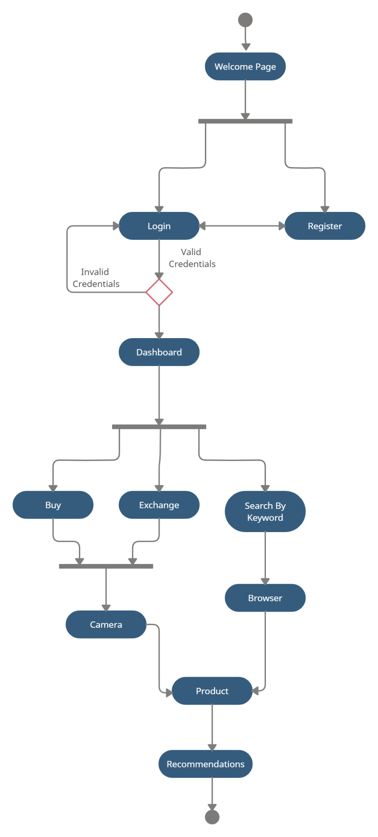

Figure 1 Activity Diagram

Activity diagram shows step by step usage of application, user will register himself if he is new user otherwise he has to login. The system will first verify the member; if username or password is incorrect he will be given warning for correct username and password. Then user needs to choose method of shopping either by taking picture or searching by key word, then application will find the desired product if there is non then some suggested items will be shown, barter exchange is also possible which can also be done through taking picture and searching.

# 4.2 Use Case Diagram

Use case diagram is used to briefly discuss the requirement of the system. It includes actors, system, user and actions performed by the specified actors. This methodology is used for system analysis and it helps in identifying, clarifying and organizing the system requirements. In this application there are two actors.

* User
* Admin

Use case diagram contains the following components:

* The boundary is used for identifying the system related with the system actors, users.
* According to the roles the actors are individually involved in the system.
* Use case defines the relationship amongst and between the actors.

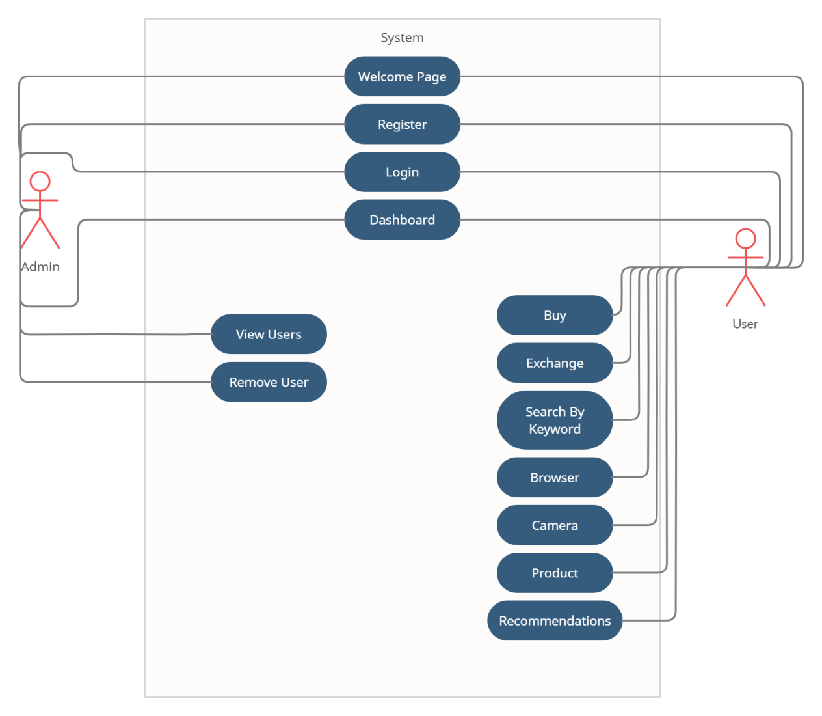

Figure 2 Use Case Diagram

The above diagram Shows different activities of the user and admin, the user will be having access to login, register, profile and products, admin will also be having access to these but admin will have some additional access, as he will be able to see users and also can delete them.

# 4.3 Context diagram

Context diagram explains the initial level of the software system, which can be further divided into sub portions. In short context, the diagram shows the brief picture of system and its relationship with other entities.

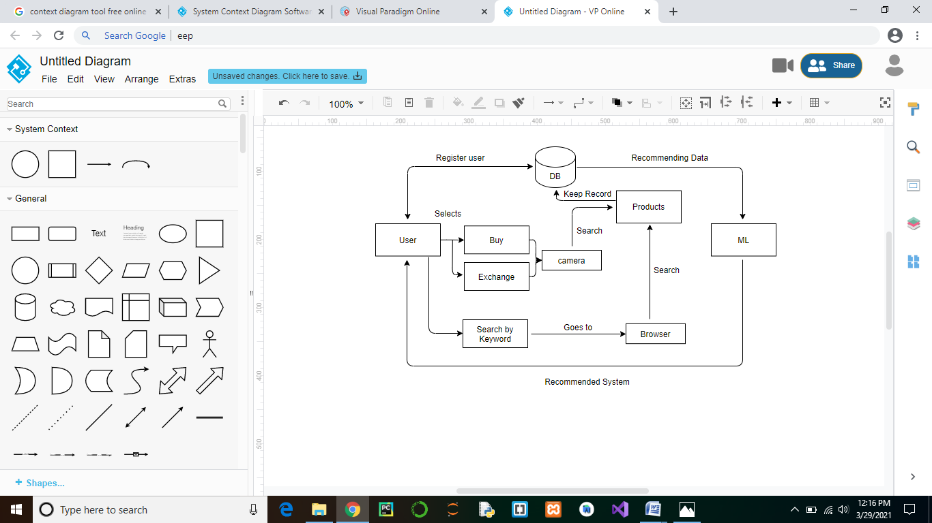

Figure 3 Context Diagram

It shows relation between different activities, as user can buy, exchange which will be through keyword or taking picture, both the activities leads to database, as data will be stored in database, which in turn will give suggestions and recommendations through machine learning.

# 4.4 Sequence Diagram

A sequence diagram is explained in the sequential events of the software system. It is represented through parallel lines which show the occurring events and at starting and ending have to horizontal lines which show the system and user respectively.

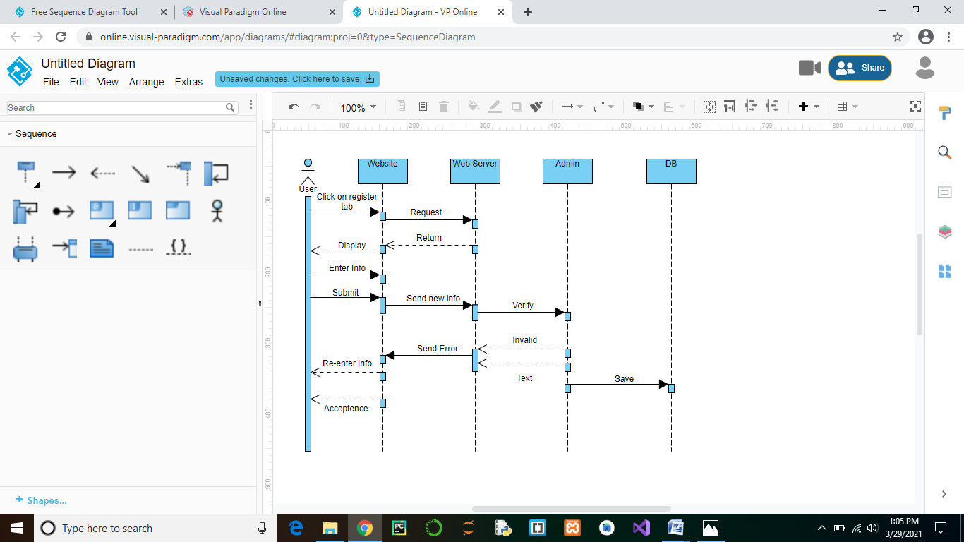

Figure 4 Sequence Diagram of User Login

Initially Users will register/login themselves. If the user details are valid according to database, then his account will be opened. If user information is incorrect or he is an existing user then error message will be shown.

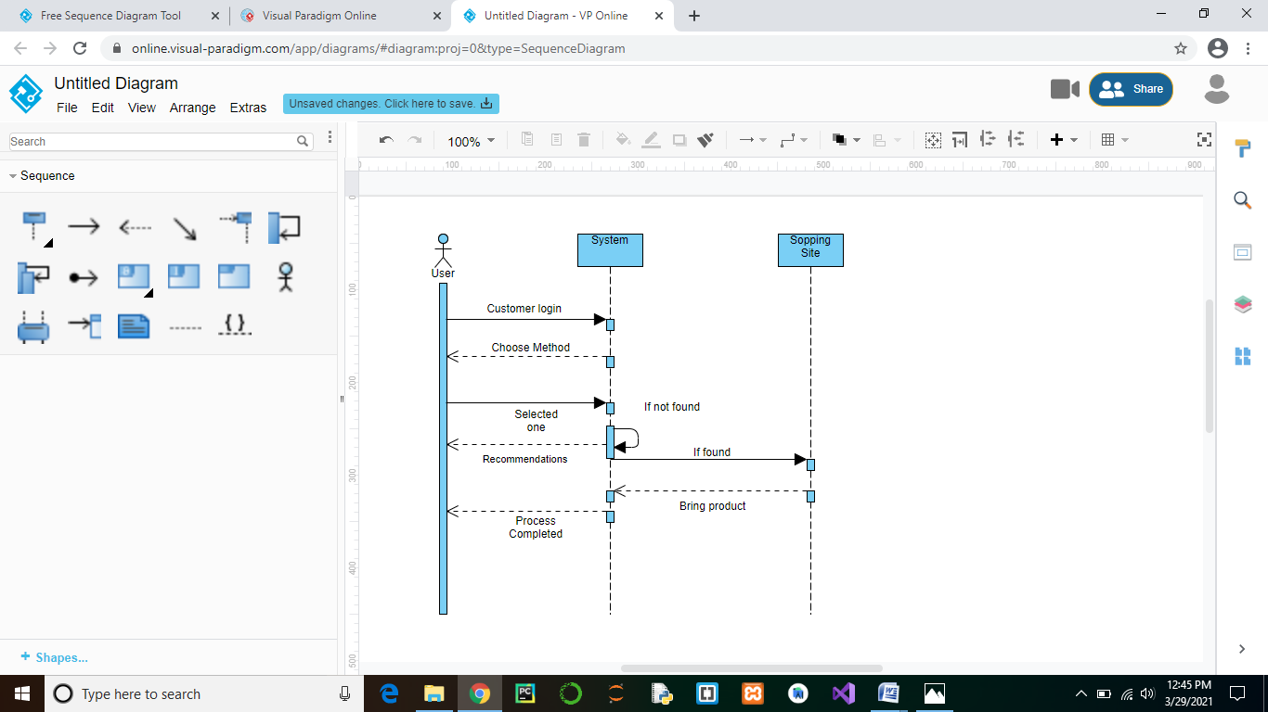

Figure 5 Sequence diagram of User Buying or Exchanging Product

User will login, if information is correct he will enter the application, next he will choose method of searching or exchange something and in next step will be finding that product, recommended items will also be shown.

**System Architecture and Features:**

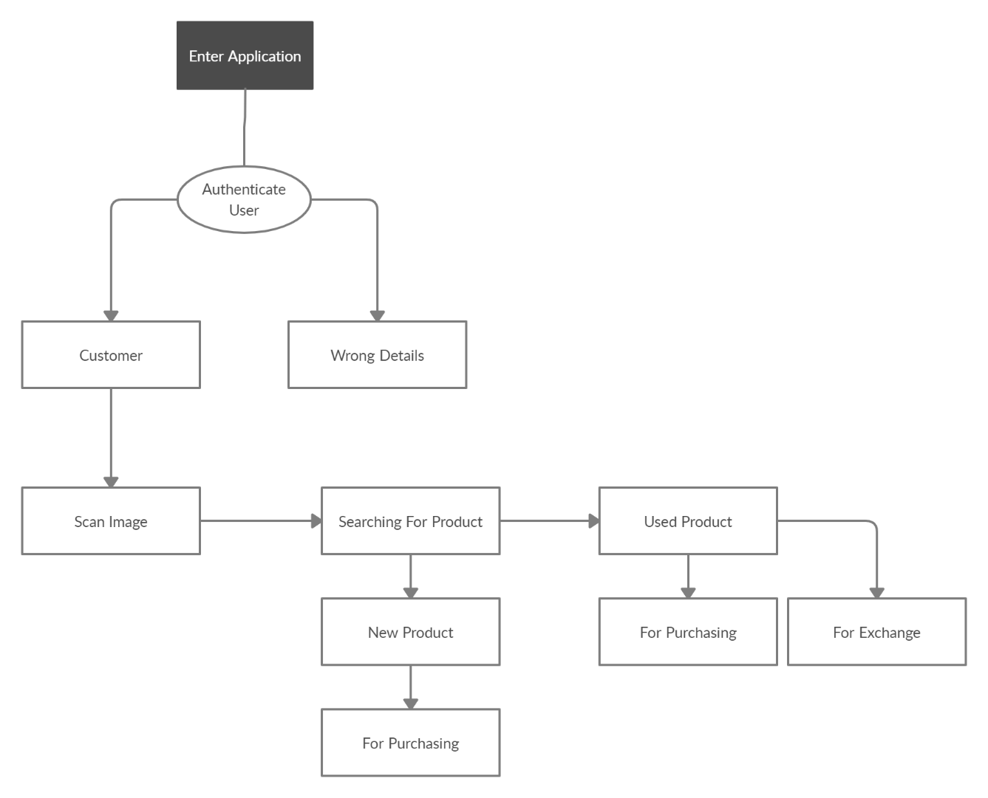

Figure 6 System Architecture

The Figure 6 shows the data flow diagram of our application. User will open our application then he/she will login by providing valid user name and password. Then he/she can scan image to find the product. After that new and used products available on different sites will be shown, from where he/she can buy or exchange products if both parties are interested in exchange.

# 4.5 Conclusion

In this chapter we discuss all the project design which include the activity diagram, context diagram, use case diagram and sequence diagram. These entire diagrams explain our project design which we discuss in this chapter. Activity diagram show stepwise explanation of the activities. Sequence diagram show sequential explanation of the system. Use case diagram show the requirements of the system. Context diagram show the initial level of the system.